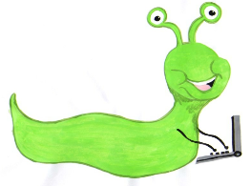 | Lyng Primary School Knowledge Organiser  Computing |  | 
Topic: Computing | How can collect and record data? | Year 1 | Summer 2


What Goldilocks and Step On words will I use?
Spelling | Defintion
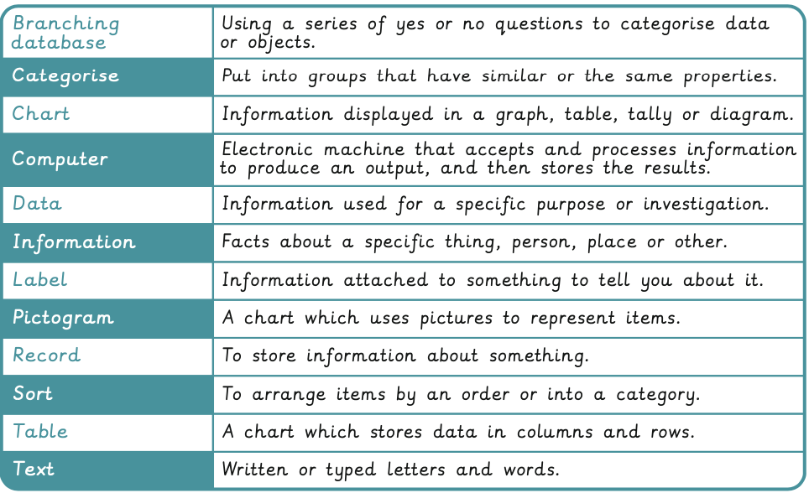
Aims of this unit
Understanding that programmes execute by following precise and unambiguous instructions. To use logical reasoning to predict the behaviour of simple programs. To create and debug simple programs To understand what algorithms are; how they are implemented as programs on digital devices; and that programs execute by following precise and unambiguous instructions.
To use logical reasoning to predict the behaviour of simple programs.
- Characters
- Grow and shrink
- Time to move
- Repeat
Safeguarding
Filtering and monitoring system is in place. Children will use their own log in details to track any misuse and to protect the child from harmful websites and pop ups. Children will be reminded of how to stay safe online and to use technology safely and respectfully and to tell a trusted adult if there is anything on their computer that makes them uncomfortable.

Outcomes
All children
- Explain what a pictogram/chart is
- Collect data
- Create simple data representations
Most children
- Understanding that technology can be used to represent data in different ways: pictograms, tables, pie charts, bar charts, block graphs etc.
- Using representations to answer questions about data.
- Using software to explore and create pictograms and branching databases.
Some children
- Interpret data
- Input data
- Decide which questions to ask
Agreed Outcome
create tally charts to record frequency and then enter this into a database to create charts and graphs representing the data.
Summer term
Data handling

Children are introduced to data collection by collecting data about minibeasts using a tally chart and represent their data digitally. They will represent the data using objects and technology, as well as using pictograms, tables and charts. They will will click and drag objects to sort data using a branching data. They will also consider the types of input that would be used to gather different forms of data when designing

:

